Publishable Version


HR COMMITTEE
DATE: | September 2021
TITLE OF REPORT: | HR Committee
AUTHOR AND CONTACT DETAILS | Gary McIntosh, Head of Human Resources gary.mcintosh@slc.ac.uk
PURPOSE: | Provide the HR Committee with a quarterly update on HR matters. Note this include the months of April to July.
KEY  RECOMMENDATIONS/ DECISIONS: | The Bo  1.  2. | ard is asked to:  Note the updates relating to staff.  Review and approve the new Equality Outcomes.
RISK | 1. | Impact of COVID-19 on the health and wellbeing of employees.
 | 2. | Business, employee and student impact of long term and/or frequent absence.
RELEVANT STRATEGIC  AIM: | Successful Students – skilled & knowledgeable staff  Highest Quality Education & Support – Valued & enthusiastic staff; high-quality support services; productive partnerships  Sustainable Behaviours – effective leadership and management; excellent governance; continuing professional learning and development; appropriate risk management
SUMMARY OF REPORT: | The report will provide insight into each of the following areas:  - Headcount Management including absences.  - Health & Wellbeing including the enablement of key people being to handle mental health situations through the targeted approach to Mental Health First Aid Training.  - Employee Engagement including: the review of processes supporting the employee journey, followed by redesign and automation, where appropriate; and the continued improvement to employee communications.  - Learning & Development.  - Performance.  - Employee & Industrial Relations.  - Maintenance of Accreditations including the requirements to: develop and automate Career Review; implement a Recognition Program and Succession Planning for management and critical roles.

1. INTRODUCTION

1.1 This paper provides an overview of HR matters for South Lanarkshire College for the period of 1st April to 31st July 2021.

2. HEADCOUNT MANAGEMENT

2.1 The quarterly headcount movement is shown in the graph below, which demonstrates a slight movement in headcount over the period, with 4 x 3rd party contractors, 1 new hire and 10 leavers.

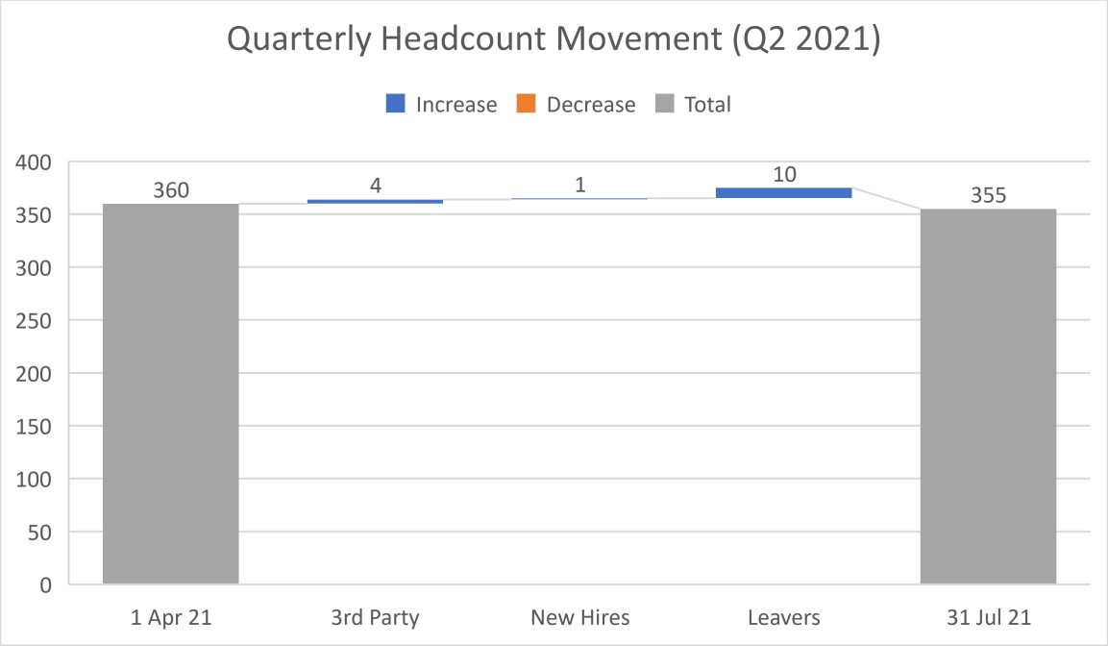

The following graph shows a comparison to the prior year, which is similar but with a higher number of new hires and one additional leaver.

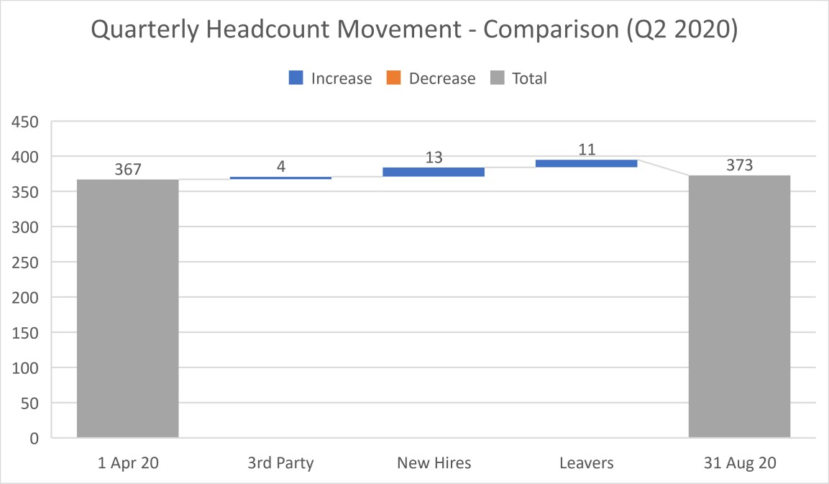

2.2 A list of new hires are included in Appendix A – not for publishing.

2.3 Recruitment

Recruitment activities during the period are shown below:

Position | Reason | Status  26th August
Campus Cycling Officer | Funded Placement | Interviews 26.08.21
Human Resources Assistant | Additional Post due to increased workload | Interviews 03.09.21
Network and Systems Support Technician (Temporary) | Additional Post due to staff absence | Interviews 02.09.21
Lecturer – Health and Social Care (Pool) | Add to Temporary Register | Interviews 10.09.21
Lecturer – Plumbing and Gas (1 FTE) | Replacement post | Shortlisting with Faculty
Employability Assistant (Fixed Term for 2 years) | SSE Sustainable  Development Fund –  EWI/IWI | Interviews 31.08.21
Lecturer – Life Science (Pool) | Add to Temporary Register | Requesting Interview Date
Lecturer – Carpentry and Joinery (0.6 FTE) | Replacement post | Shortlisting with Faculty
Lecturer – Administration and IT (1 FTE) | Replacement post | Interviews 13.09.21
Training and Employment Assistant | Maternity Cover | Interviews 31.08.21
Associate Principal – Faculty of Business | Replacement post | Badenoch and Clark
Graphic Design and Digital Lead | Maternity cover | To be advertised
Lecturer – Painting and Decorating (Permanent 0.65 FTE) | Replacement post | Shortlisting with Faculty
Student Funding Assistant (Fixed Term for 12 months) | Additional post due to increased workload | Closing date 01.09.21

2.4 Leavers

A list of leavers are included in Appendix B – not for publishing.

2.5 Absence (not for publishing)

3. HEALTH & WELLBEING

COVID-19 and mental health initiatives continue to be at the forefront of our Health, Safety & Wellbeing efforts.

3.1 COVID-19

The situation is beginning to normalise and therefore support staff numbers have carefully increased on campus. Faculty colleagues and students have been on summer holidays for some of this period and will be returning to campus in a careful, managed way with oncampus priority being given to practical class content and delivery.

We have enhanced communications with our students and Student Association, employees, trade union representatives and leadership to ensure we are hearing views from right across the College, as well as engaging with peers in other Colleges and in the wider College community.

We continue to follow our protocol agreed with NHS Lanarkshire as required and to submit our weekly COVID-19 statistics to the Scottish Government.

The College issued an updated COVID-19 Health & Wellbeing guide, revitalizing our benefits for colleagues to support themselves during the pandemic. The benefits continue to be popular and beneficial and include TogetherAll, PAM Assist (our Employee Assistant Program), Access to Work Mental Health Support Service and a range of engaging activities to maintain a degree of connectedness or support wellbeing. In addition, The College Leadership Team continue to regularly review the situation, discuss issues for employees and seek to deliver tailored solutions.

3.2 Mental Health

Mental Health Working Group

The Group continues to meet on a regular basis to review and offer solutions for identified mental health challenges across the College. The last meeting was on 17th March 2021 and primarily focussed on the mental wellbeing of employees and students as a result of COVID19.

The Group is currently utilising social media platforms to signpost in house support services to students and staff, and to share information on mental health awareness campaigns.

Mental Health First Aiders

We recently confirmed plans to train and support 30 members of staff as Mental Health First
Aiders. Over 40 members of staff submitted interest in undertaking the role and following an Introduction to Being a Mental Health First Aider briefing session outlining role responsibilities, 24 have signed up to courses planned for August, September, October and November.

Mental Health Funding

The College received additional funding towards mental health and wellbeing support during the 2021/22 academic year. The funding will be allocated between both student and staff groups. An action plan to implement improvements to services, initiatives and events is underway.

HSE Organisational Stress Risk Assessment

The College has appointed a partner to run a survey in support of this Organisational Stress Risk Assessment that will both ensure the anonymity when completing the survey and also allow for anonymous interaction should the College wish to gather additional insights from comments made. This work is supported by members of a Short Life Working Group, made up of a cross-section of college staff and supported by Trade Union colleagues.

The survey has now concluded with a high response rate of 83%. Results vary across the key areas of focus within the Organisational Stress Risk Assessment, which considered change management; role demands; role control; managers’ support; peer support’ relationships; role. As can be seen from the table below, understanding of role is our highest scoring area of focus (81); and our management and communication of Change (51) is our lowest scoring area.

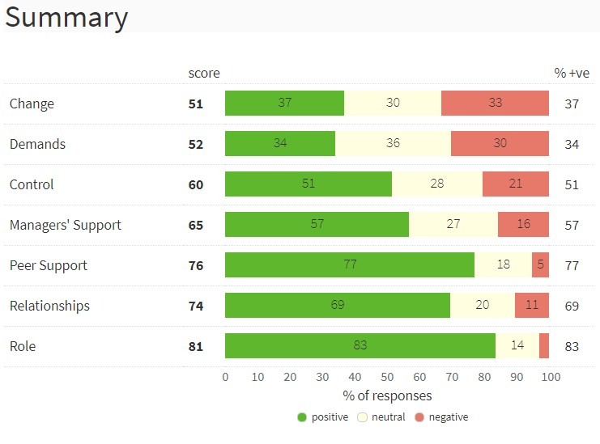

Staff were provided with a more detailed faculty/departmental read-out to allow for local discussions during the staff development days. These were well received and will form the basis of local action plans to respond to the survey findings which will feed into a wider CLT consideration of a corporate action plan for the College. Initial feedback from staff has been very positive.

4. EMPLOYEE ENGAGEMENT

The College is about to embark on an optimization of our approach to employee engagement to improve the current approach and to introduce a planned, data-driven approach.

4.1 Employee Journey & Experience

The College will enhance HR-related processes and implement appropriate automation to improve the employee journey and experience. We will be sourcing a process specialist to join the team around October for around 6-9 months to support this.

4.2 Employee Engagement & Internal Communications

We had a very engaging, remote Staff Conference on 10th and 11th August which, following business and sector updates, included College-wide engagement with all employees around our strategic priorities, values and survey results. In addition, we had a range of engaging activities including staff performances to showcase talent, a remote “Escape Room” and a guest speaker. A summary of evaluation data will be provided in the next HR Committee report.

4.3 Equality, Diversity & Inclusion

The Equality Group met on Monday 7th June, when a number of items were actioned and discussed. A key focus of the meeting was to review progress of Equality Outcomes and the Equality Mainstreaming Report.

Equality Act – Public Sector Equality Duty
We have an obligation to take actions to meet the specific duties of the Public Sector Equality Duty (PSED). The College has identified new Equality Outcomes for the HR Committee review and approval. They are:

- Outcome 1 – Develop the engagement of underrepresented students and staff groups through an increase in tailored peer support groups.
- Outcome 2 - Annual engagement with three organisations to enable and progress our recruitment and management of employee and students across identified underrepresented groups.
- Outcome 3 – Use proactive marketing and communicating during recruitment, onboarding and throughout the student and employee journey to increase awareness and promote the fostering of good relations, tolerance and respect for diversity. Ensure that at least 90% of these populations have awareness of equality and diversity practices.
- Outcome 4 – Ensure at least 90% of staff undertake equality, diversity and inclusion training and that all students offered training to ensure awareness and understanding of legal and College expectations for everyone in our community.

S1Jobs Recruitment Awards
In July, we were finalists in the s1jobs Recruitment Awards 2021, Best Diversity & Inclusion Initiative category. The ceremony will take place on August 27th.

Disability Confident Employer
In August, we successfully achieved Disability Confident Employer accreditation. This means that, as an employer, the College is proactive in ways to recruit disabled people and have mechanisms in place, ensuring that people with disabilities and long term health conditions, feel supported, engaged and able to fulfil their potential in the workplace.
This is part of our commitment to recruiting and retaining the best people. Being a Disability Confident employer means we are better placed to recruit people with disabilities, so we can build strong and effective teams.

4.4 Employee Recognition

In June, we launched a trial staff recognition programme ‘Employee Star Awards’ to celebrate employees who live the college values and contribute to the success of the college. Colleagues were asked to recognise their peers and nominate for defined categories. A panel selected 9 winners and made special recognition for the IT and Facilities teams given their particular contribution throughout the pandemic. We streamed a live awards ceremony to all staff to celebrate the recognition awards as a collective. Following success, the development of a formal recognition framework is underway.

5. LEARNING & DEVELOPMENT

5.1 The following graph show the current learning & development activities across the College.



ng
Onboardi
First Aid
Manager's Career
Review Briefing
CMI Management
Training
In Progress
5
1
6
8
Complete
5
3
26
9
0
5
10
15
20
25
30
35
Number of Employees
Staff Training Programmes
Complete
In Progress
5.2 The following graph shows the current Professional Development activities across the College. The new TQFE and PDA cohorts will begin in September 2021. A brief explanation of each qualification is noted below:

TQFE – The Teaching Qualification in Further Education is the recognised in-service teaching qualification for FE lecturers in Scotland. The qualification is completed at Degree (SCQF 9) or Postgraduate (SCQF 11) level.

Professional Development Award (PDA) Teaching in Scotland’s Colleges – Qualification at SCQF level 9 intended for college lecturers who have subject specific expertise but no formal teaching qualifications. The PDA is used to prepare staff for progression to the TQFE.

Assessor and Verifier Awards – Qualifications for assessors and verifiers of regulated, taught qualifications. Ensures consistency in application of quality assurance and that occupational competence requirements of lecturers are met.



TQFE
PDA Teaching in Scotland's
Colleges
Assessor and Verifier
Awards
In Progress
0
0
6
Complete
8
9
11
0
2
4
6
8
10
12
14
16
18
Number of Employees
Professional Development
Complete
In Progress

5.3 Staff Development Day

To thank staff for their hard work and continuous effort needed to support delivery of our services in the last academic year, we scheduled a day of sessions and activities that provided the opportunity for staff to relax, collaborate and enjoy time to focus on their wellbeing. We were also able to celebrate our own staff talent with sessions delivered by a number of staff members across different specialist subjects.

A total of 13 sessions were delivered on Wednesday 23rd of June with 352 staff bookings. The sessions were delivered as our 7th virtual staff development day and
95% of staff said sessions were ‘Excellent’ or ‘Good’.

Prior to sessions starting, an all-staff Introduction to Outlook session was delivered to support the implementation and migration from Groupwise to Microsoft Outlook, due to take place in October.

The following table shows the number of employees who participated in each course and the average satisfaction scores.

Staff Development Day – 23rd June 2021
Course | No. Employees | Satisfaction (out of 4)
Introduction to Outlook | 144 | 3.6
Wednesday Wake Up – Let’s Dance | 26 | 3.8
Baking Demo – Afternoon Tea | 39 | 3.7
Virtual Fitness Challenge | 22 | 3.9
Mindful Gardening (2 sessions) | 20 | 3.9
Virtual ‘Happy Hour’ | N/A | N/A
Financial Wellbeing | 11 | 3.0
Mindfulness | 12 | 3.5
Virtual Art Class | 15 | 3.6
Signing Choir | 6 | 4
Devenny’s Summer BBQ – Virtual Cooking Demo | 45 | 3.7
Virtual Quiz! | 12 | 3.5
TOTAL | 352

6. PERFORMANCE

It is essential to ensure the College continues to be strategically aligned with
performance. Two areas of development for this are through team development with the College Leadership Team and also through Career Review conversations with all employees.

6.1 College Leadership Team – Team Development

The College Leadership Team participated in an event on 23rd June 2021 where we reviewed the team results of a specific survey on CLT operation and ambition and had healthy discussions and workshops on our ideas on how we will further develop as a team. The next steps will be agreed before we proceed.

6.2 Career Review

The Career Review process is in the final stages of development. The process has been automated and content developed to include strategic priorities, values and a focus on career goals. Training with the management team on the new process has taken place with final feedback being implemented. The system will be launched in September for a new cycle of career reviews.

7. EMPLOYEE & INDUSTRIAL RELATIONS

7.1 Contracts of Employment and Job Descriptions
Contracts of Employment and job descriptions for College Management and Lecturers are currently being reviewed. The JNC is involved in these discussion as follows:

- Curriculum Managers: as a result of national bargaining, CMs are now deemed ‘promoted lecturer level 3’ and have had a salary increase to reflect this. APs are currently reviewing the CM job descriptions in line with the NJNC national agreement. The revised contracts of employment for this cohort are being prepared for issue by the end of October 2021. It is recognised that additional support and training may be required to support delivery of new tasks.

- Lecturers: Revised Contracts are being prepared following national bargaining agreements. All contracts have now been issued for Permanent Lecturers. Temporary Lecturer contracts are pending a clarification with the trade union. The revised contracts of employment for this cohort are being planned for issue by the end of October 2021.

- Deputy Head of Faculty: (3 staff) - job descriptions and contracts being prepared. The revised contracts of employment for this cohort are being prepared for issue by the end of October 2021.

- Heads of Department: job roles were previously evaluated and further work is required to review salaries (currently being undertaken as part of the national evaluation) and to update Contracts to reflect three months notice period. The revised contracts of employment for this cohort are being prepared for issue by the end of September 2021.

7.2 Employee Relations

Q1 2021
Q2 2021
Q3 2021
Q4 2021
Grievance
1
1
Disciplinary
1
0
Capability
0
0
Other
1
1
0
1
2
NUMBER OF CASES
EMPLOYEE RELATIONS ACTIVITIES
Grievance
Disciplinary
Capability
Other

Note: there is no reliable, comparative data available for the sector, nationally, etc.

7.2 National Issues

The support staff settlement for 2020/21 has now been concluded and the confirmation received from Colleges Scotland. This was provided within the May pay run.

We are awaiting the outcome of the job evaluation exercise for support staff.

7.3 Review of HR Policies & Procedures

The HR Policy & Procedure Review process remains in train, commencing with the prioritised documents shown below, along with their status.

Document | Review Status
Code of Practice for Employee Competence | Being replaced with an Employee Capability procedure – draft is currently being reviewed with JNC
Grievance Policy & Procedure | Being updated, in accordance with ACAS guidelines
Disciplinary Policy & Procedure | Being updated, in accordance with ACAS guidelines
Dignity at Work | Not yet started
Code of Practice on Whistleblowing | Not yet started
Managers’ Charter | Not yet started

Colleges Scotland are also reviewing a higher-level agreement for the Grievance & Disciplinary policies, which ours will continue to be aligned with.

Note: other policies and procedures are being prioritised due to them being requirements for accreditations: Recruitment & Selection, Reasonable Adjustment; Flexible Working Requests; Disability Policy; Code of Conduct; Staff Learning & Development; Gender Identity Policy; Mental Health and/or Wellbeing Policy.

8.0 Maintenance of Accreditations

Maintenance of all three accreditations identified the following key actions, which are all currently in train:
- Alignment of Career Review process with strategic priorities and values.
- Automation of Career Review process.
- Create and implement a College-wide recognition program.
- College-wide succession planning focussed on all people manager and critical roles.

Details of the prior recommendation for each accreditation is shown below.

Investors in People
Investors in People is due for renewal in December 2021. We have commenced discussions and planning with Mary Leishman, our new Account Manager from Re:markable, to progress our renewal.

Recommended actions from the previous award in 2019 are:

- Align management charter with changes in leadership role
- Define behaviours associated with values more explicitly
- Align the values, behaviours and management standards more formally
- Ensure consistency of managers’ capabilities in agreeing challenging and motivational objectives, providing feedback and recognising high performance as part of Career Review process
- Link personal objectives to team and College objectives.
- Consider methods of reward and recognition for high performance.
- Stronger focus on continuous improvement by leveraging feedback from students and staff
- Develop a formal succession plan to recognise high performers.

One early action is the automation of our Career Review process, which has been manual, hard to access and hard to report on. This is progressing well.

Investors in People Health and Wellbeing
Investors in People Health and Wellbeing Award is also due for renewal in May 2022. We will assess our progress towards this as part of our overall Accreditations renewal action plan. Recommended actions from the previous award in 2019 are:

- Raise greater awareness of how the values and the Management Charter drive the development of a healthy working environment.
- Line managers to more visibly support physical, psychological and social health and wellbeing.
- Promote the successes and recognise the less effective activities in relation to health and wellbeing.
- Consider competitive challenges that encourage participation and engagement.

Leaders in Diversity
Leaders in Diversity renewal has been delayed due to COVID-19. We are working with them on a planned renewal during 2021 as this accreditation lapsed in September 2020.
Recommended actions from the previous award in 2019 are:
- Manage inappropriate behaviours
- Further engagement to ensure a sense of inclusion and ownership with diversity
- Open up more mental health training and consider online counselling
- Enable understanding of unconscious bias
- Help managers feel comfortable and confident in managing practices around diversity • Enable people to feel a fairness for all in the College
- Ensure cross-College communication and performance management including diversity
- Managers to be more vocal regarding diversity to employees

We continue to progress the work around re-accreditation with the support of our staff and have established a short-life working group made up of a varied cross-section of staff to take this forward. It is proposed that meetings take place on a fortnightly basis with accountability to the College Leadership Team. It is anticipated that the work of the SLWG will be concluded by 30 September 2021.

Recognising that Equality Diversity and Inclusion (EDI) encompasses so much we launched FREDIE. FREDIE adds in the principals of Fairness and Respect to our EDI agenda and recognises the importance of Engaging with our colleagues and customers.

APPENDIX C

Equality Act – Public Sector Equality Duty Outcomes and Themes (2017 – 2021)

Theme 1A: Provide equality of opportunity in recruitment, promotion and professional development of staff.  Theme 1B: All College strategic and operational decisions, associated policies, procedures and business processes are impact assessed in line with the three needs of the PSED.  Theme 1C: Students and staff will understand the purpose and use made of personal data and feel confident disclosing confidential information relating to all protected characteristics. | Theme 2A: Provides  excellent facilities and resources to meet the needs of students and staff.  Theme 2B: Students and staff fully understand and comply with the College policy in relation to equalities.  Theme 2C: All students and staff are fully informed of the benefits of full disclosure of protected characteristics to advancing equality. | Theme 3A: Curriculum choice, design and delivery models offer students access to qualifications that meet their needs and ensure equality of outcomes.  Theme 3B: Proactively engages with students to ensure understanding of needs, aspirations and potential barriers to success.
Outcome 1  Demonstrate leadership and commitment and strive to eliminate discrimination, advance equality and foster good relations | Outcome 2  Offer a breadth of curriculum choice that meets the needs and aspirations of all learners, including those from underrepresented groups | Outcome 3  All learners will have an equal opportunity to come to college and achieve positive outcomes

Theme 4A: Provide equality of opportunity to prospective and current students, in relation to entry, retention and achievement.  Theme 4B: Performance indicator data relating to recruitment, withdrawal and success are analysed and action plans put into place to ensure reasonable adjustments are made to support equality of outcomes for all students. | Theme 5A: Staff knowledge of equality and diversity is continually developed and positively influences employment experiences and development.  Theme 5B: Actively identifies, adopts and shares good practices in relation to equalities. | Theme 6A: Engage with national, regional and local equality forums and contributes to wider discussions on equality issues with stakeholder organisations.
Outcome 4  Increase engagement with stakeholders to develop a better awareness of equality  of opportunity for a developed workforce | Outcome 5  Learners will have increased opportunity for progression into organisations that value equality and diversity | Outcome 6  Ensure that equality is embedded in all that we do and is supported by the appropriate regional  resources

